Electronic Records Express (ERE)

User Guide for

Send Individual Responses



August 2018
Table of Contents
Overview 2
Requirements for Access to the Electronic Folder 2
Logging into the Appointed Representative Services 2
Appointed Representative Services Main Menu 3
How to Use Send Individual Response 3
Step 1: Destination and Request Information 4
Step 2: Barcode Information 4
Step 3: Attach and Upload Files 5
Step 4: Tracking Information 8
Logging Out of ERE 9
Timing Out 10
Avoiding User Errors 10
ERE Electronic File Format Options: 10
Access Keys 10

Overview
This guide provides Social Security Administration (SSA) claimants’ appointed representatives with detailed instructions for viewing and downloading documents in their claimant’s electronic folder.

Requirements for Access to the Electronic Folder
- You must have a User ID and a self-selected password;
- The claimant’s file must be electronic at the Hearing or Appeals Council level; and
- The link Send Individual Response must be displayed on the Electronic Records Express Home page under the Evidence Functions heading.

Logging into the Appointed Representative Services

Log into Business Services Online at https://secure.ssa.gov/acu/LoginWeb/loginHandler.do?SUITE=AR

NOTE: You must open a single browser session to log into the Appointed Representative Services to access electronic folders. After login, do not open multiple browser sessions to open electronic folders and review or download files.

The User ID and password for the Appointed Representative Services cannot be used on other Social Security Administration website login pages. The login will fail and be considered an invalid attempt. After a certain number of invalid login attempts, your User ID may be suspended.

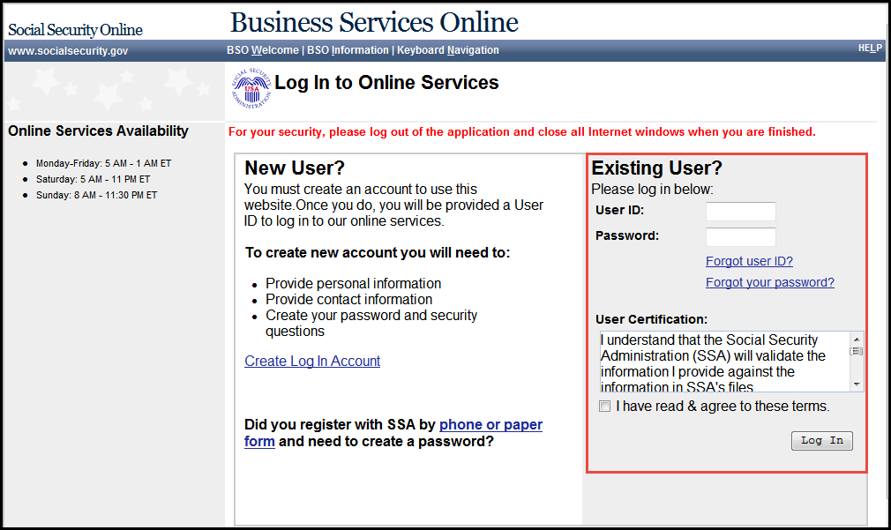

Appointed Representative Services Main Menu
The main menu displays information about ERE authorized services, Appointed Representative registration, and account management.

Select Enter ERE.

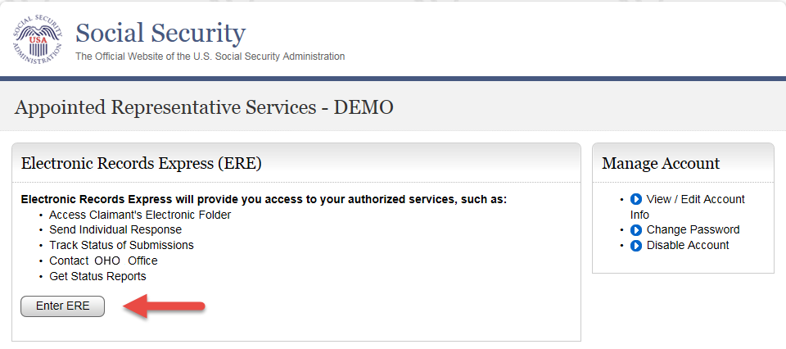

How to Use Send Individual Response
On the ERE home page under Evidence Functions, select Send Individual Response.

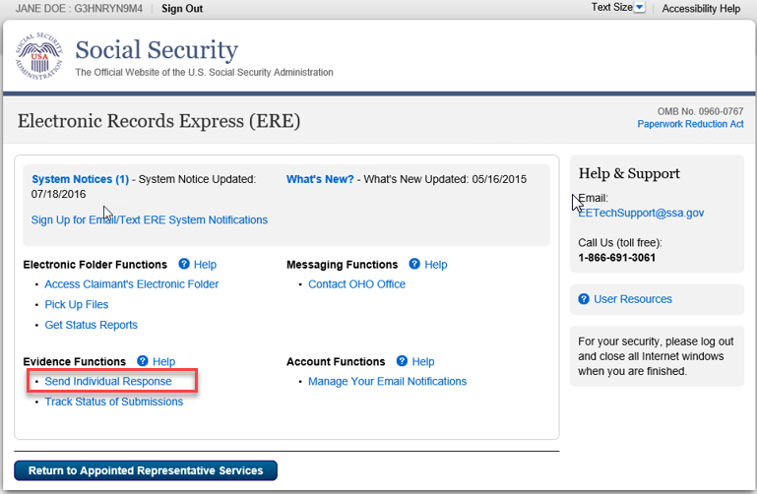

Step 1: Destination and Request Information
- Enter the OHO site code in the Site Code field in the Destination and Request Information section.
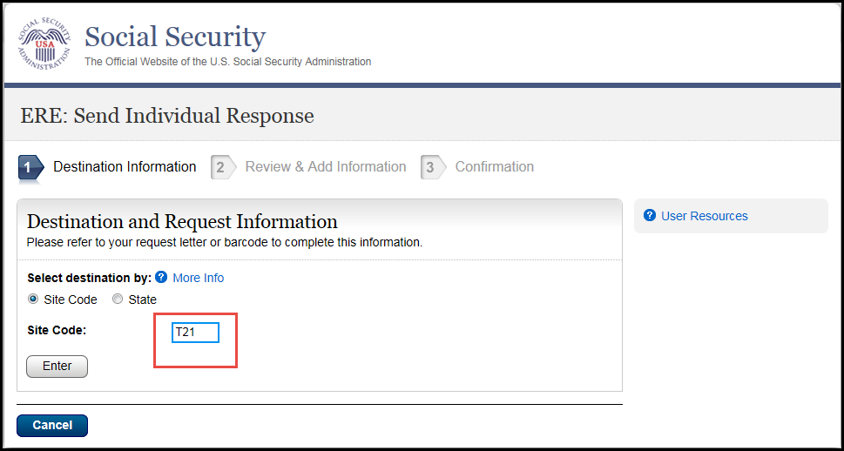
Select Enter

Step 2: Barcode Information

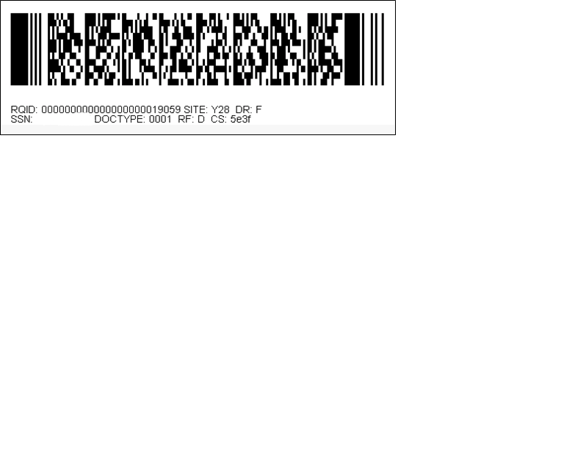
From the barcode provided by OHO, enter the following information in the appropriate fields.
- Claimant’s SSN
- RQID (Request ID): Enter the RQID beginning with the first non-zero number. For example, if the barcode shows RQID as 00000001102400, enter 1102400.
- RF (Routing Field)
- DR code
- DO NOT enter the CS code.

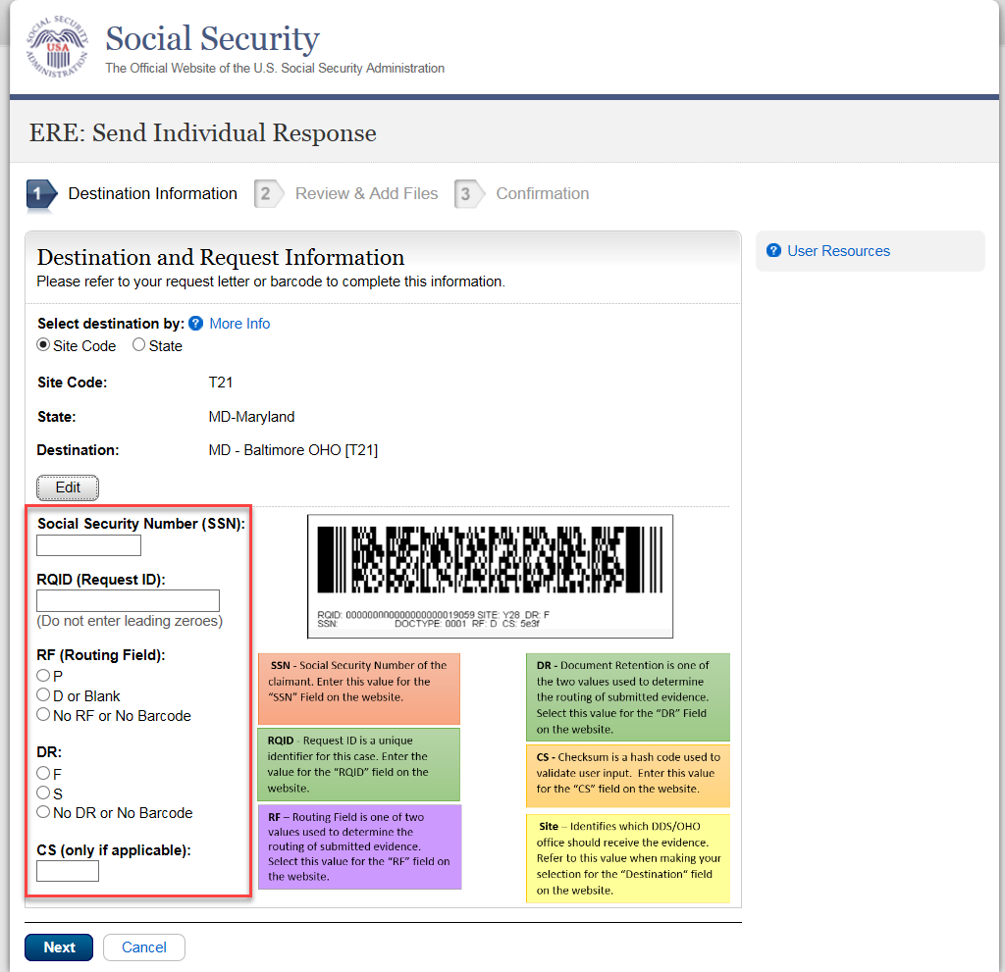

Select Next.

Step 3: Attach and Upload Files
In the Attach and Upload Files section, you can send electronic files from your computer to OHO.

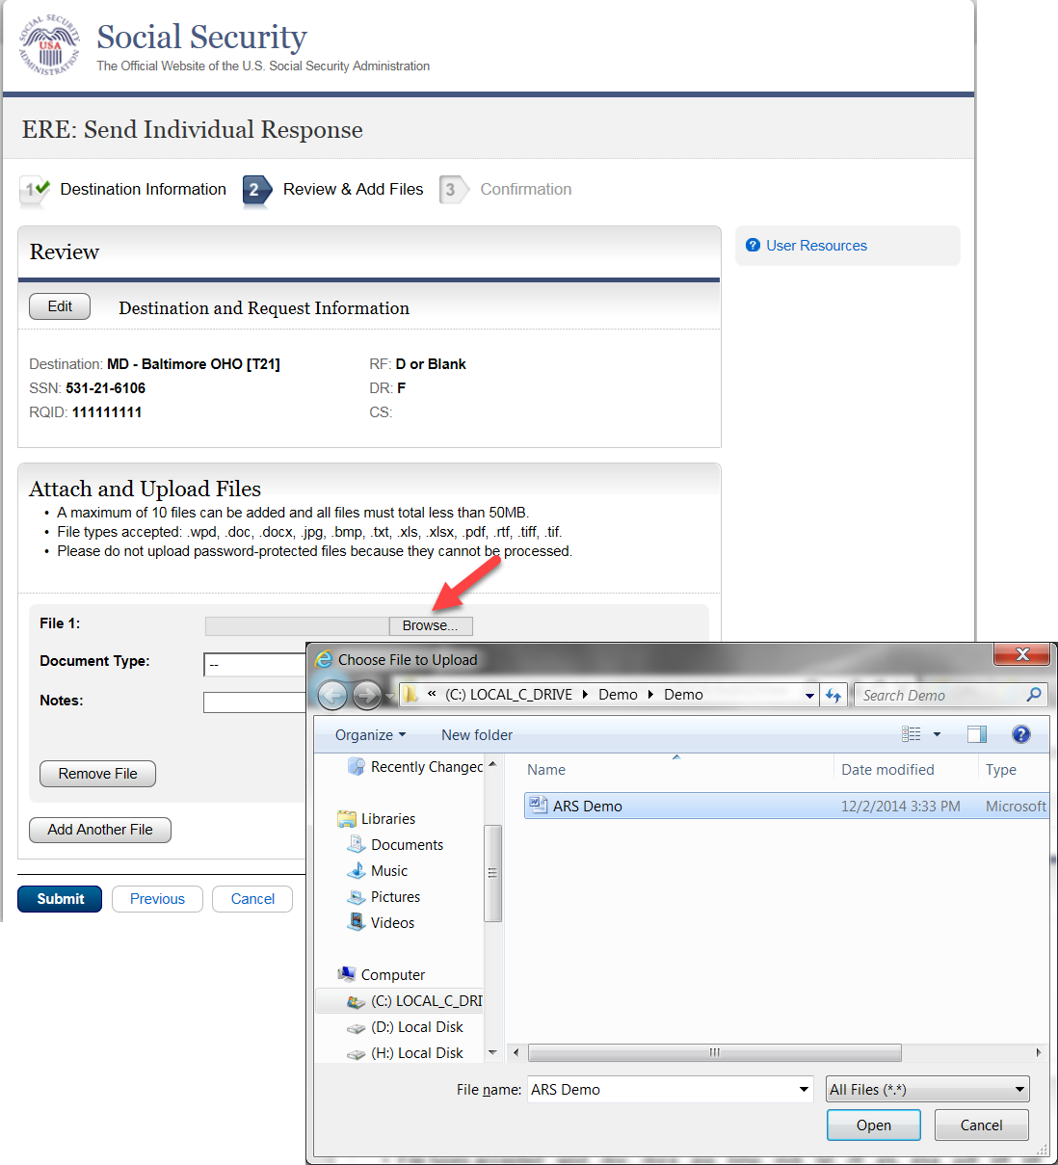

- Select the Browse button; this will launch the Choose File to Upload window.
- Using the Choose File to Upload window, select the file you wish to send to the electronic folder. The document’s file name will insert into the File name field at the bottom of the window.
- Next, select the Open button.
- The Choose File window closes and the file name displays in the field to the left of the Browse button. You have successfully attached the file.
- Document Type: Select from the drop down list a document type for the document you are sending.
- Depending on the document type you select, additional fields may appear which require completion.
- Select Submit or add additional files by selecting Add Another File.

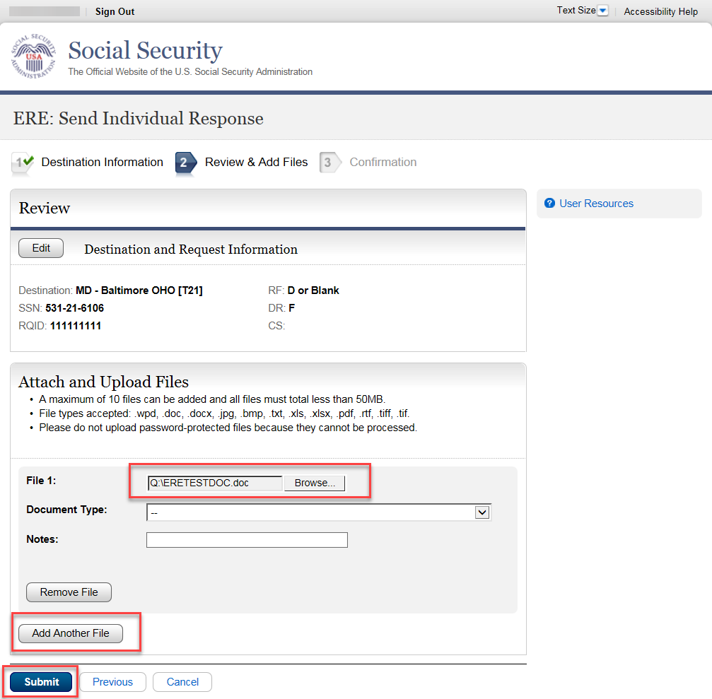

Step 4: Tracking Information
You should receive a Confirmation screen acknowledging that SSA has received your transmission. The transmission must still go through an SSA systems check before being sent to the electronic folder. You will be notified by email if there are any errors or problems that prevent SSA from processing your submission. NOTE: We recommend that you print this page for documentation. You will not be able to retrieve this information from SSA (including OHO) after you exit this page. 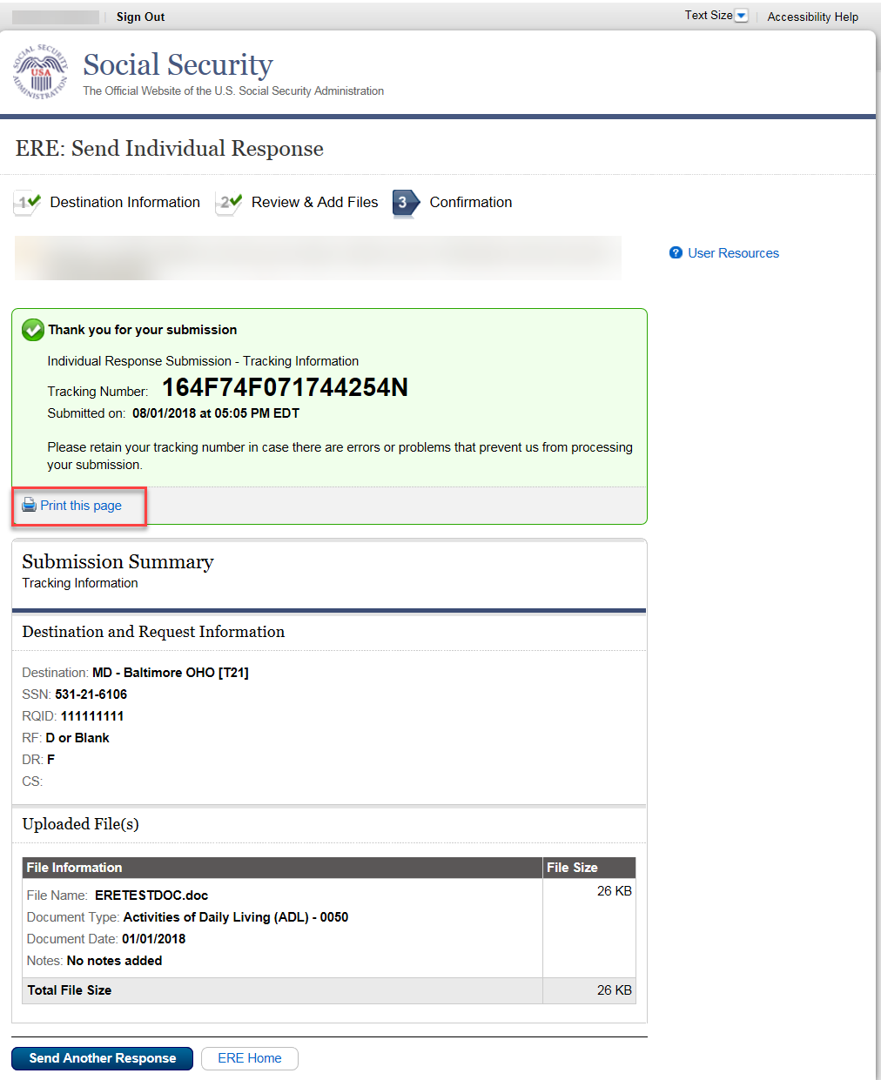
If you have evidence to send for another claimant, select the Send Another Response button.

Logging Out of ERE
When you have completed your file uploads, select Sign Out on the top left of the page. Logging out ensures that others may not access the ERE website through your Username and Password.

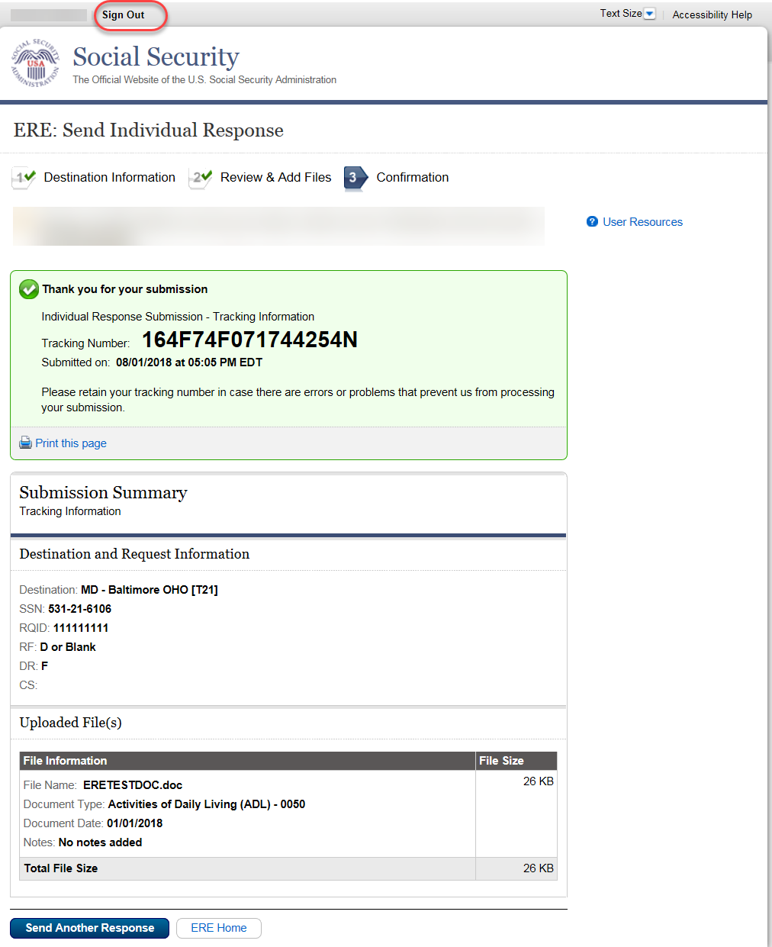

Timing Out
The website will time out after 30 minutes of inactivity. After 2 hours, the website will log you out and you must re-enter your User ID and Password to continue.

Avoiding User Errors
Errors can occur for many reasons. The following list briefly explains some common ERE website user errors:
- Bookmarking the Confirmation page – Never bookmark pages within the ERE website.
- Once you have submitted documents by selecting the Submit button, you should NOT use the Back button or close your Internet browser file until you receive the Confirmation page.

ERE Electronic File Format Options:
The ERE website currently supports the following file formats:
.wpd | .doc | .txt
.pdf | .xls | .jpg
.bmp | .tiff | .tif
.docx | .rtf | .mdi
 | .xlsx

Access Keys
ERE contains access keys to improve navigation and provide information. You will find a list of these keys in the table below:

Button/Link | Access Key
Next | n
Submit | P
User Resources | u

NOTE:
- To use these keys on Windows-based browsers select the Alt button on your keyboard and the access key simultaneously. On the Mac, use the Ctrl key.
- Internet Explorer Browser Users Only: In order to trigger the Browse button you will need to use the space bar if you are using keyboard access.

